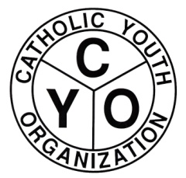

DIOCESE OF BROOKLYN CYO DAY AT YANKEE STADIUM
SUNDAY MAY 4th, 2014
1:00pm
NEW YORK YANKEES vs TAMPA BAY RAYS
COME OUT TO YANKEE STADIUM TO ENJOY A BEAUTIFUL SPRING DAY OF BASEBALL AS A CYO FAMILY TO HELP RAISE FUNDS FOR YOUR CYO PROGRAM AND THE DIOCESE OF BROOKLYN CYO.
TICKET COST OPTIONS:
- $22.00 per ticket for seats in the Outfield 400 section. For each $22.00 ticket sold your CYO program will receive $5.00.

- $55.00 per ticket for seats in the Outfield 200 section. For each $55.00 ticket sold your CYO program will receive $10.00.

CYO Baseball games WILL NOT be scheduled for 5/4/14. Please encourage members of your program to come out to Yankee Stadium to support the Catholic Youth Organization. We ask members of CYO Baseball teams to wear their uniform jersey.
To order tickets please contact the CYO office:
AnnMarie Creighton @ 718-281-9548 or acreighton@diobrook.org
Ticket orders must be placed by April 7th with payment to the CYO office.

